Welcome Back
A Happy New Year to everyone!!

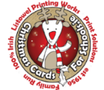Thank you to all who bought Christmas cards. We raised €85.00 for the school.
School Closed Tuesday 20th January 2026 Primary Curriculum Framework training for teachers.
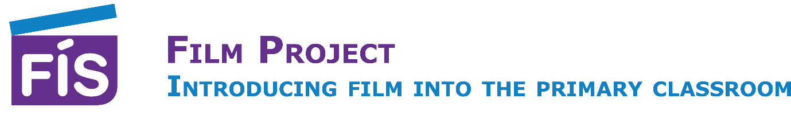
Exciting news! We will travel to the Helix in Dublin 12th February 2026 for the FÍS Film Awards. More details to follow.

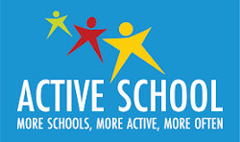Active Break Challenge Jan 19th – Feb 13th 2026
The Active Break Challenge for 2026, is a whole-school initiative encouraging short, frequent movement breaks (3-5 mins) integrated into the school day.

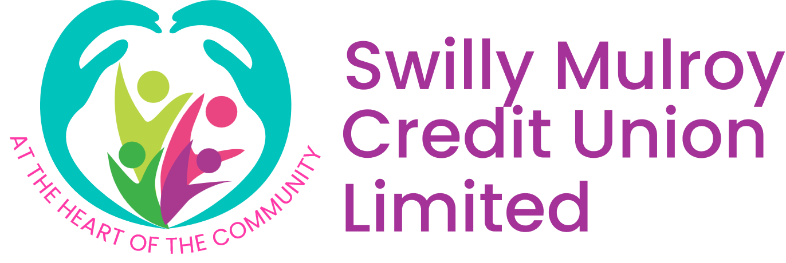Credit Union will return to St. Garvan’s NS in January 2026.
The Credit Union Quiz will be held on Friday 6th February 2026 in Rossnakill Resource Centre at 7pm. Only 8 children from the senior room will be selected to go. More details will follow on WhatsApp.

Catholic Schools Week:18th – 24th January
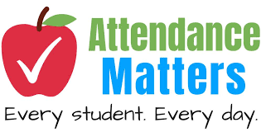 A gentle reminder. If your child is absent it is important to let the teacher know in the morning and the reason for the absence.

Thank you.
Róisín Hannigan
Principal

