Whole School Mathematics Plan- March 2025

Introduction

This primary school is based in Drumhalla with 34 pupils. The school has 2 mainstream classrooms, 1 SET teacher and an SNA. This Whole School Maths Plan was devised in consultation with the whole staff taking from their experiences of teaching in our school.

Rationale

The curriculum describes Mathematics as the study of relationships, connections and patterns that surround us. It encompasses key values that every child is mathematical, that mathematics is both a human and social phenomenon, that mathematics is a tool that helps us to make sense of the world, that it is beautiful and worthy of praise in its own right and that maths is everywhere and for everyone.
In this document we aim to outline how we propose to implement the Maths Curriculum in our school with consideration for our particular setting with DEIS status. This document considers and aims to provide for all children in the school from those in need of extra supports to those achieving outside of the average ability.

Our Ethos

We aim to enable the pupils in our care to achieve their maximum potential in a happy, safe, inclusive, child-centred environment. We strive to nourish and develop each child's sense of their own self-worth as an individual and celebrate their unique gifts and talents. We support each student to grow academically, socially and spiritually in a warm, caring, respectful environment.

Aims

Conceptual Understanding: the comprehension of mathematical concepts, operations and relations.

Procedural Fluency: the ability to use a variety of mathematical procedures in an effective and efficient way.

Productive Disposition: the tendency to see Mathematics as practical, useful and worthwhile.

Adaptive Reasoning: the capacity to use logic to understand, explain and justify one’s thinking.

Strategic Competence: the skill to devise, represent and solve mathematical problems.

Understanding the New Primary Maths Curriculum
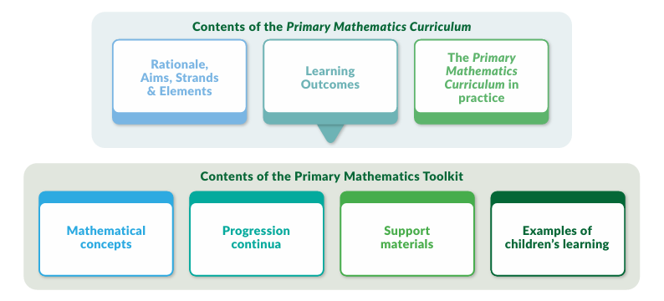
Strands outline the main categories of mathematical learning across five content areas as outlined in the table below taken from the curriculum. These are further broken down into elements as can be seen below. Learning Outcomes (L.O) are outlined for each element and are broad in their scope. Learning Outcomes need to be evident in teacher planning.

The Primary Maths Toolkit is a support resource for teachers to help them to hone and refine their planning to suit the needs of their class and setting. Mathematical concepts and progression continua give teachers more detail and guidance on how they may approach teaching and moving through a specific topic.

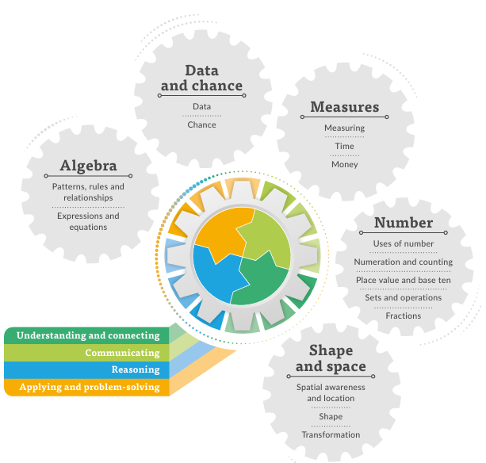

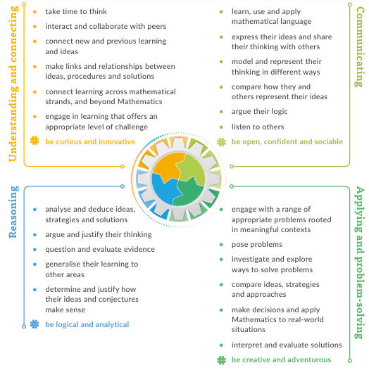
Pedagogical Practices and Approaches
The curriculum outlines some key pedagogical practices for use in the classroom in the teaching of Maths as follows:
  - Promoting Maths Talk
  - Using Cognitively Challenging Tasks
  - Fostering Productive Disposition
  - Emphasising Mathematical Modelling
  - Encouraging Playfulness
These pedagogical practices allow for children to learn and develop at a pace and level of challenge that is individual to their needs and interests whilst developing their confidence and proficiency in Mathematics. As with most good classroom practices, these practices are dynamic and naturally link with each other.
Individual Teachers Planning
Teachers should base their yearly and short-term plans on the approaches set out in this whole school plan for maths and the primary maths curriculum. Each class teacher will familiarise themselves with the objectives for their own class level. Each teacher will bear in mind that in planning, a balance between the strands should be kept throughout the year. Work covered will be outlined in the Cuntas Míosúil. It is recognised that the purpose of planning is to aid and benefit the teacher and that the layout and design of the planning is at a teacher’s personal discretion.
Teachers are required to show evidence of the Learning Outcomes chosen in their planning.

Concrete Resources
Each class will be provided with a set of resources based on their class level that are designed to support the teaching of number primarily but may be adapted to be used in other strands of the curriculum. Resources that will be used less regularly will be collated and stored at a central location and a list of these resources will be distributed to all teachers for their reference. Stock takes will be carried out to keep track of, organise and replace missing equipment. Teachers may request to purchase additional resources through school management for their individual classes or for the shared resource area of the school. A list of the available resources is attached to this document.

Books
Classes from Junior Infants to Sixth class are working from the Operation Maths Programme and books are purchased annually that the children can write into. We will adopt a new Maths Programme collectively in the future and books will be purchased as part of the school book scheme that children will not write into and will remain the property of the school. The current Mental Maths book that is being used is Operation Maths and the children are writing into these. Teachers at all levels are encouraged to use their discretion in the use of books in relation to the Maths Curriculum. Teachers are under no obligation to complete the entirety of any book and should feel free to leave out or supplement any section of a textbook from other sources based on what they feel is most beneficial to the children in their class.

Technology
Every classroom is provided with an Interactive board which can be used to support the teaching of maths through providing online games, online manipulatives, access to support materials for Operation Maths, mathematical videos and songs etc. Ipads are also available to teachers for use in the exploration of mathematical topics. A list of useful websites is attached to this document.

Assessment and Record Keeping
Assessment is used by teachers to inform their planning, selection and management of learning activities so that they can make the best possible provision for meeting the varied mathematical needs of the children in our school. Teachers use several tools for assessing pupils’ work.
Teachers will keep a record of children’s mathematical work in their assessment folders as a way of tracking children's progress. The records kept in every teacher’s folder is at their own discretion and may include but is not limited to:
- samples of children’s work
- formal tests/assessments
- photographs of work with concrete materials
- teacher observations
- records of teacher conferences with children
- peer and self-assessment
It is not required that classes carry out termly assessments, but it is required that teachers have some evidence of children’s progress in Maths in their assessment folder.
Standardised tests will be carried out at the end of every year and results will be uploaded to Aladdin and made available to the incoming teacher.

Teaching for Student Ability
The maths programme aims to meet the needs of all children in the school. This will be achieved by teachers varying pace, content and methodologies to encourage learning for all children. This curriculum acknowledges the experience of teachers and their skill level in assessing and recognising where their own classes are in terms of ability and mathematical experience and skill. A teacher at any level in our school, will start at the mathematical level of the children they are meeting in their class on a given year. Where classes are year on year in terms of academic achievement may vary for many different reasons and influences so setting out a programme for achievement at every class level is unrealistic in this setting. As a school, we trust our teachers to establish where a class is in terms of their mathematical learning through collaboration with previous teachers and assessment and to work forward from that point. In line with this, programmes for children in Special Education settings within our school will be chosen and administered by the teachers in these classrooms as they see fit.
The introduction and development of each topic will be structured in a graded, sequential way to allow the individual child to develop and participate at their own level and pace. When a child demonstrates a particular difficulty, either with a topic, strand or overall, the class teacher will provide extra support and assistance to the child. This may be supported informally with in-class support from the SEN team. This kind of support would not require permission from a child’s parents as it would be provided as part of a whole class setting and would not require withdrawal.
While the ideal is that all children learn as part of a whole class group and that children from various settings would be integrated for Maths, it is recognised and acknowledged that this is not always possible. Integration for Maths lessons will be discussed and decided between the Special Class teacher and the associated class teacher. Consultation between the class teacher and SEN teacher may result in the decision that withdrawal and more focused support is necessary for some children.
The availability of supplementary teaching for Maths, however, depends on the case load of the S.E.T team. Arrangement will be in accordance with the recommended selection criteria as determined by the DES and laid out in the school’s SEN policy. The class teacher and SEN teacher may decide from their assessments and interaction with children that other children are in more need of support at a given time and may rotate groups or children receiving varying levels of support. Support will include various models depending on needs of child/class. Should it be decided that withdrawal is required, parents will be notified, and permission will be sought if not already given.
Children with exceptional ability in maths will be given extra work based on the concept being taught in class to enable them to reach their full potential. Parents will be consulted and opportunities for further development will be explored.

Useful Weblinks
https://www.scoilnet.ie/primary/theme-pages/mathematics/
https://polypad.amplify.com/p
https://mathsbot.com/
Topmarks: teaching resources, interactive resources, worksheets, homework, exam and revision help
https://www.mathplayground.com/
https://toytheater.com/
https://www.twinkl.ie/resources/roi-resources/discover-thrive-twinkl-ireland-resources
Resources
We are looking at drawing up an inventory of maths resources and will purchase new resources that are required.
The area of school textbooks will be examined especially for senior classes for 25/26.

Success Criteria
The success or otherwise of the plan will be gauged from a variety of sources ranging from teacher feedback to learner outcomes being achieved to standardized test results. The plan is being introduced in stages and whole-school focus will be developed accordingly.

Roles and Responsibility
Development and progression of Math curriculum from whole-school level will be led by the principal through use of croke park hours / staff meetings and teacher communications.
The following people have particular responsibilities for the ongoing monitoring of the policy: Class Teacher, pupil, Principal, Parent/Guardian, post-holder. BOM to provide oversight role.

Timeline for Implementation
2023/2024: The new Primary Math Curriculum was introduced in.
Teachers to become familiar with new terms and focus

October 2023 Principal and DP leader attend seminar in Education centre
December 2023 School Closure day 1 for staff CPD – Education centre
Action- Staff to explore : Maths Talk

2024/ 2025:
October 2024 School Closure day 2 for staff CPD
May 2025 Purchase of new concrete math materials for class sets.
The proposed date from which this whole school plan will apply is September 2024.

2025/2026 Embedding the Primary Math Curriculum in our school.

Ratification & Communication
The policy was presented to BOM and ratified on _____________ and communicated to the school community.

The IPPN recognises the contents and aspirations of Circular Letter 0045/2019 and the subsequent document – Preparation for Teaching and Learning – Guidance for All Primary and Special Schools. These plans are offered as a guidance tool - a support offered by members for members and are not designed to replace or reduce the collegial professional dialogue and planning that is expected of schools and supported by Oide and the Department of Education and Skills. We thank the colleague who volunteered this but the IPPN does not take responsibility for errors within or the failure of this document to reflect accurately best practice or latest thinking.

Circular Letter 0045/2019 Section 5 School and Classroom Planning Effective school and classroom planning for teaching and learning is important in order to become familiar with the Primary Language Curriculum/Curaclam Teanga na Bunscoile (PLC/CTB). Schools and teachers should decide on the best approach to planning based on their own individual contexts. ….. 7 At school level, planning should help the school to provide for implementation of the PLC/CTB so that continuity and progression in pupils’ learning are promoted. At classroom level, planning should ensure sufficient preparation to support high quality teaching and learning and support language learning for all pupils. The process of planning for teaching, learning and assessment gives teachers an opportunity to consider how best to implement the PLC/CTB in their own settings and to consider how to support the next stages of children’s learning. Preparation for teaching clarifies the learning outcomes on which the class is working; the specific approaches chosen by the teacher to support pupils’ in achieving those outcomes, and the way in which the teacher will assess and monitor pupils’ progress. The process of planning varies from teacher to teacher but they should: • Plan in accordance with the particular needs, aptitudes and interests of the children in their classroom • Plan in accordance with the learning outcomes set out in the PLC/CTB Stages 1–4, 2019 • Use their professional discretion to decide how to plan for teaching and learning, drawing on their knowledge of pupils’ learning strengths and needs, and how these are best met • Use a template or planning rubric that best suits their needs. This approach can allow the practitioner to engage and think about implementation in a way that makes sense to them, while keeping the principles of the PLC/CTB to the fore. Arising from this approach, teachers individually and collaboratively will move towards creating a methodology for planning that is useful in guiding their practice, in their own context. • Ensure that the focus of planning is on the provision of rich and authentic language learning experiences for children which will support their achievement of the outcomes set out in the PLC/CTB. The Department understands that planning at this stage of implementation of the PLC/CTB is tentative and dynamic, reflecting teachers’ growing knowledge and understanding of the new curriculum and responding to the needs of the children in their classrooms. As such, the Department advises teachers to develop clear, short-term, language learning plans which are reflected upon, evaluated and amended in the light of experience.

The IPPN recognises the contents and aspirations of Circular Letter 0044/2019 and the subsequent document – Looking at Our School 2022: A Quality Framework for Primary Schools and Special Schools.

