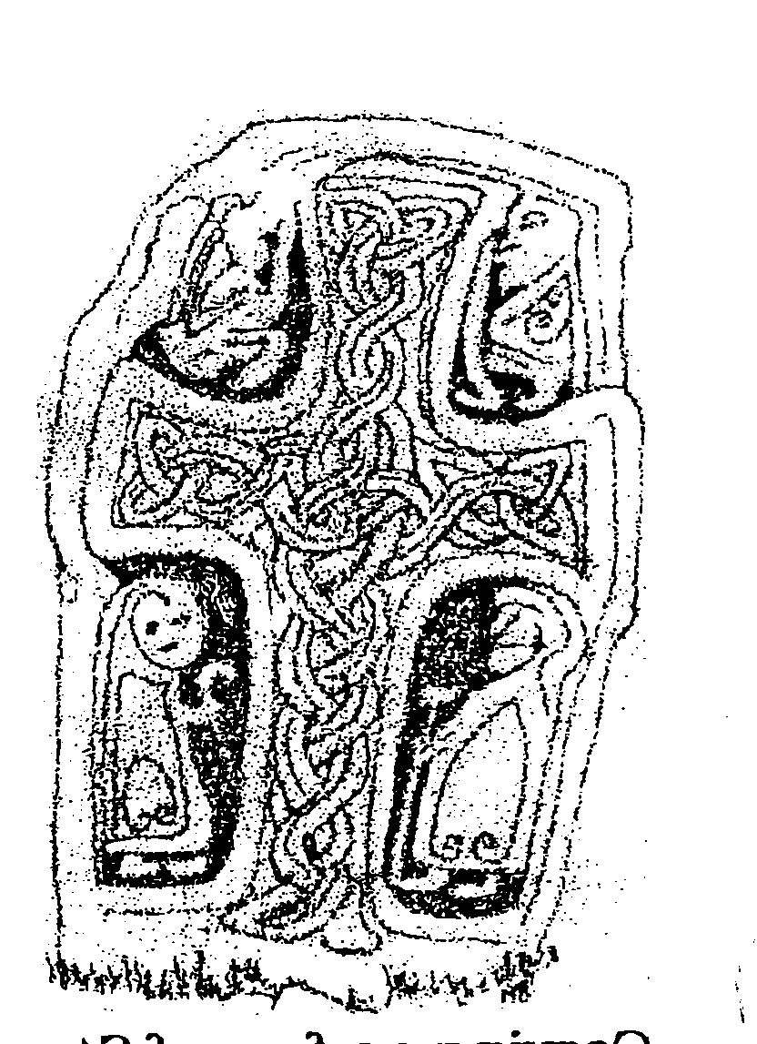

St Garvan’s N.S, Enrolment Form 2026-2027
The Department of Education and Skills has developed an electronic database of primary school pupils called the Primary Online Database (POD) which involves schools maintaining and returning data on pupils to the Dept at individual pupil level on a live system. This information will be used to evaluate progress and outcomes of pupils at primary level, to validate school enrolment returns for grant payment and teacher allocation purposes, to follow up on pupils who do not make the transfer from primary to post primary level and for statistical reporting. The database will hold data on all primary school pupils. The database will also contain, on an optional basis, information on the pupil's religion and on their ethnic or cultural background. The data required for POD is marked with an asterisk *and will only be uploaded to POD if your child is enrolled. All other data we need for the efficient running of the school. In order to assist with the gathering of data please complete the form in CAPITAL LETTERS and return to the school. This form will be retained by the school.

* Pupil First Name: _________________________________ *Pupil Surname: ______________________________

* Birth Cert First Name (if different from above) * Birth Cert Surname (if different from above)

_________________________________________________ _______________________________________________

* Pupil Address: __________________________________________________________________________________

* Date of Birth:_____________ *PPSN _________________* Gender Male [ ] Female [ ]

* Mother’s maiden name ________________________ * County _____________ *Nationality _______________

*Is one of the pupil’s mother tongues (i.e. language spoken at home) Irish or English Yes [ ] No [ ]

* Religion _______________________________

Do you consent to uploading data relating to religion to POD Yes [ ] No [ ]

* To which ethnic or cultural background group does your child belong (please tick one)?

White Irish [ ] Irish Traveller [ ] Roma [ ] Black African [ ]

Any other White Background [ ] Any other Black Background [ ] Chinese [ ] Any other Asian background [ ] Other (inc. mixed background) [ ]

Do you consent to uploading data relating to ethnicity to POD Yes [ ] No [ ]

The following information is required for the efficient running of the school and will not be uploaded to POD

*E-mail:__________________________________________________

Previous School attended if applicable:___________________________________________________________________

Mother’s Name: _____________________________ Telephone No. _________________________

Father’s Name: ________________________________ Telephone No: _________________________

I do /do not give permission for my child to receive additional help from Learning Support in school. (Parents will be notified should it be recommended that their child would benefit from L.S)

Medical History (including any relevant reports assessments) :

___________________________________________________________________________________________________

___________________________________________________________________________________________________

Allergies: __________________________________________________________________________________________

Medication: ___________________________________________________________________________________

Doctor Name & Phone Number: ____________________________________________________________________

If Parent(s)/Guardian(s) not available, please contact: ______________________________________________________

Please make the school aware as early as possible of any family situation such as bereavement, or separation that could impact on your child, so that we can be as supportive as possible.

*Other Parent address needed for reports:________________________________________________________________

Please answer YES or NO to the following (please circle as appropriate):

- Our child is allowed to take part in the relationships & Sexuality Education (RSE) Programme:

YES : NO
- Our child can be taken to hospital in case of emergency if we can not be contacted: YES : NO

- Inclusion of our child’s photographs on our school website: YES : NO

- Inclusion of our child’s photographs in a local/national newspaper: YES : NO

- The Information may be shared with other agencies e.g H.S.E, who require it: YES : NO

- Our child’s uniform being changed by adult member of staff in the presence of another adult in case of illness or toilet accident: YES : NO

- Use of a nominated mobile number by the school for Text-a-Parent and emergencies. Please nominate one mobile number:

_____________________________________

- We have received and read a copy of the “Code of discipline” : YES : NO

- We will support & co-operate with the staff of the school: YES : NO

Signature Parent/Guardian 1: Signature Parent/Guardian 2:

___________________________ ______________ ____________________________________

Date: ____/____/____

NB: Please ensure that a photocopy of the child’s BIRTH CERTIFICATE is returned along with this Enrolment Form,

The following will be filled in by the school

Child’s Class: __________________ Teacher’s Name: _______________________________

